
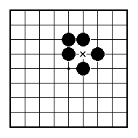
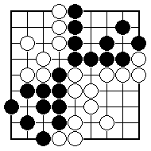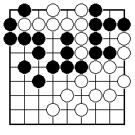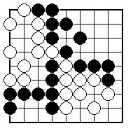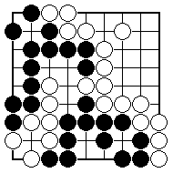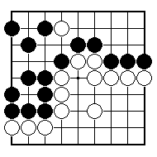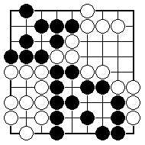
White to play; what is happening?

Black to play; what is happening?

Black to play; what is happening?

White to play; what is happening?

Black to play; what is happening?

Black to play; what is happening?

NAME:
BRITISH GO ASSOCIATION CERTIFICATE LEVEL 3 - SHEET 11

WHOLE BOARD SITUATIONS

